Jejunum and ileum
Extends from duodenum to the ileocecal junction
Length
Jejunum ~ 2.5 meters
Ileum ~ 3 meters
Suspended in the abdomen through the mesetery

Blood supply

Arterial supply
By jejunal and ileal branches of superior mesenteric artery

Venous drainage
By corresponding veins drain to superior mesenteric vein (portal vein)

Lymphatic drainage
Drain to nodes along superior mesenteric artery and vein
Later the lymph enters cisterna chyli to drain into throcic duct

Lymphatics of small intestine carries major portion absorbed lipids
It can also spread cancer from intestines

Innervation
Parasympathetic supply by vagus nerve
- Secretion of glands and motility

Sympathetic supply - splanchnic nerves
- Controls blood supply to the gut, also influences motility and glandular secretions

Functions

Jejunum
Absorb sugars, amino acids and fatty acids

Ileum
Absorbs particularly absorbs Vitamin B12 and bile acids
Also absorbs sugars, amino acids and fatty acids

Difference between jejunum and ileum
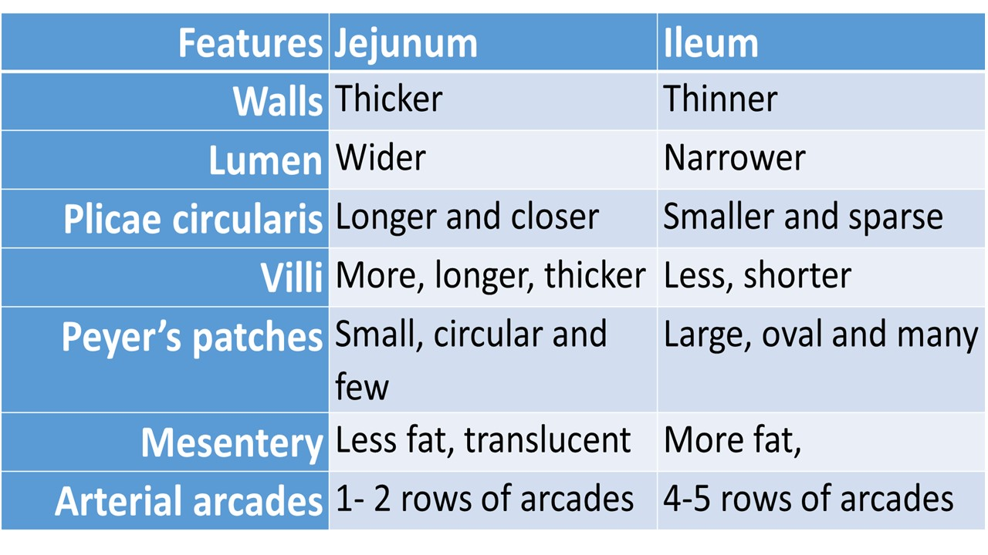

Capsule endoscopy
A small wireless capsule sized camera takes images of gastrointestinal tract

